**Heart Failure Detection through SMOTE for Augmentation and Machine Learning approach for Classification**

, Department of Computer Science & Engineering, Prasad V Potluri Siddhartha Institute of Technology, Vijayawada, mail:

, Department of Computer Science & Engineering, Prasad V Potluri Siddhartha Institute of Technology, Vijayawada, mail:

, Department of Computer Science & Engineering, Prasad V Potluri Siddhartha Institute of Technology, Vijayawada, mail:

, Department of Computer Science & Engineering, Prasad V Potluri Siddhartha Institute of Technology, Vijayawada, mail:

, Department of Computer Science & Engineering, Prasad V Potluri Siddhartha Institute of Technology, Vijayawada, mail:

**Abstract:** Chronic heart failure represents a widespread global health challenge, necessitating innovative approaches for early detection and management. While pharmaceutical interventions play a pivotal role, there is a growing recognition of the adjunctive benefits of exercise in addressing this condition. In this study, we implement the Synthetic Minority Over-sampling Technique (SMOTE) to augment our dataset and harness a comprehensive suite of machine learning algorithms, including XG Boost, k-Nearest Neighbors (KNN), Adaboost and Support Vector Machines (SVM), to enhance the model's efficacy in early heart failure detection. The rigorous validation process through cross-validation techniques underscores the paramount significance of this research in the medical field. By enhancing our capacity to identify heart failure at its incipient stages, this study holds the potential to save lives by enabling timely interventions. It underscores the promising role of machine learning in advancing healthcare and highlights the critical importance of early detection and intervention in managing this pervasive global health issue. Chronic heart failure demands multifaceted solutions, and this research represents a significant stride in the quest for improved detection and management. By integrating machine learning techniques and acknowledging the role of exercise in therapy, this study offers a comprehensive approach to address this pressing health concern and paves the way for a more proactive and effective response to chronic heart failure on a global scale.

**Keywords:** Synthetic Minority Over-sampling Technique, machine learning algorithms, heart failure, cross-validation, healthcare

**1. Introduction**

Heart failure is a significant global health concern, as emphasized by reports from the World Health Organization (WHO). This medical condition is characterized by the heart's inability to effectively pump blood, resulting in a range of debilitating symptoms and complications. The WHO reports highlight that heart failure affects millions of individuals across the world, and its prevalence is increasing, particularly in aging populations. The impact of heart failure extends beyond individual health, straining healthcare systems with elevated hospitalizations, rising healthcare costs, and decreased patient quality of life. The condition is associated with a high mortality rate, underscoring the critical importance of early detection and effective management in reducing its global burden [1]. Heart failure, a pervasive chronic disease affecting a substantial global population, necessitates early detection and intervention to mitigate its impact and improve patient outcomes. While pharmaceutical treatments play a central role, the recognition of exercise as a valuable adjunct therapy in heart failure management is gaining prominence. In response to this pressing healthcare challenge, this study focuses on advancing heart failure detection through a machine learning-based approach, leveraging patient health parameter data. Early detection is vital, with the potential to save lives and reduce the burden of this worldwide issue. Our research encompasses the utilization of nine machine learning algorithms and introduces the innovative Principal Component Heart Failure (PCHF) feature engineering technique, strategically designed to enhance performance by selecting the most crucial features [2].

Heart rate variability (HRV) serves as a valuable method for the detection and assessment of congestive heart failure (CHF). Previous research on HRV has predominantly focused on linear and nonlinear indicators derived from ECG signal RR intervals. However, this article introduces a novel sequence that offers insight into the sympathetic and parasympathetic nervous system's influence on heart rate regulation. Leveraging multi-fractal detrended fluctuation analysis (MFDFA), the study quantitatively evaluates the complexity of this new sequence to discern differences between healthy individuals and those with CHF. The results shed light on how disruptions in autonomic nerve control due to physiological and pathological factors can lead to a reduction in the complexity of heart rate signals, enhancing our understanding of CHF-related alterations in HRV [3]. The diagnosis and management of Heart Failure (HF) represent on-going challenges for healthcare systems globally, particularly with the growing number of individuals in aging populations surviving cardiac conditions but still facing residual heart function impairment. To address this critical issue, the implementation of Point-of-Care (PoC) measurement of N-terminal pro-B-type natriuretic peptide (NT-proBNP) emerges as a potential game-changer. NT-proBNP, released in response to cardiac wall stretch, allows for serial measurements that can serve as a valuable indicator of HF progression or deterioration, thereby assessing the effectiveness of HF interventions [4].

Heart failure as a potential consequence of cancer treatments has emerged as a significant concern in the realm of oncology and cardiology. Early detection and prediction of cardiotoxicity in cancer patients are of utmost importance to mitigate the risks associated with heart failure. This study focuses on the integration of genetic data and Electronic Health Record (EHR) data to identify cancer patients at a high risk of developing treatment-related heart failure. By employing four machine learning models, including Logistic Regression (LR), Support Vector Machines (SVMs), Random Forest (RF), and Gradient Boost (GB), we aim to harness the power of data-driven approaches to enhance predictive accuracy. Our investigation delves into various strategies for combining genetic and EHR data, ultimately striving to provide a comprehensive and effective solution for the early identification of cancer patients susceptible to cardio toxicity [5]. The accurate detection of arrhythmias holds paramount importance in clinical settings, as it serves as a crucial indicator of acute and chronic cardiac conditions, significantly impacting patient well-being. However, due to inherent variability among individuals and the presence of inevitable noise, this task is challenging even for seasoned medical experts. This paper embarks on an exploration of the potential of deep neural networks, specifically recurrent and residual architectures, in the classification of ECG recordings. The study leverages a dataset comprising ECG readings from 162 patients, encompassing three distinct classes: normal sinus rhythm, cardiac arrhythmia, and congestive heart failure [6].

The heart, a vital organ in the human body, serves the essential function of pumping blood through its intricate network of vessels, muscles, and valves. Heart disease encompasses a range of conditions that affect this intricate system, including the development of heart failure, a prevalent and growing health concern. Heart failure signifies the heart's inability to meet the body's demand for blood, although it doesn't necessarily mean a complete cessation of pumping action [7]. Heart failure signifies the heart's inability to meet the body's demand for blood, although it doesn't necessarily mean a complete cessation of pumping action. With the increasing incidence of heart failure among both older and younger individuals, early detection and diagnosis have become pivotal in mitigating the associated risks. Various factors, including underlying diseases like diabetes, can elevate the risk of heart failure, making machine learning models a valuable tool for assessing this risk based on patient data [8].

**2. Literature Survey**

M. Gjoreski, et.al, [9], chronic heart failure (CHF) detection, combining classic Machine Learning (ML) and end-to-end Deep Learning (DL) techniques, has shown promising results. With an impressive aggregated accuracy of 92.9%, it outperforms the recent PhysoNet challenge's baseline method by a significant margin, underlining its potential as a valuable tool in CHF diagnosis. Additionally, the identification of 15 expert features for distinguishing between CHF phases with an accuracy of 93.2% highlights its versatility. These findings offer hope for more accessible CHF patient identification and the development of home-based monitoring solutions, potentially reducing hospitalizations and improving the management of this widespread medical condition.

W. Ning, et.al, [10], highly effective automatic congestive heart failure (CHF) detection model, utilizing a hybrid deep learning approach involving a convolutional neural network (CNN) and a recursive neural network (RNN). The outstanding accuracy of 99.93%, sensitivity of 99.85%, and specificity of 100% for 5-minute ECG signal analysis surpass previous research efforts, marking a significant advancement. Furthermore, our investigation into CHF patient detection using ultra short-term ECG signals yielded excellent results. This hybrid deep learning algorithm offers an objective and accurate means of classifying CHF signals, demonstrating its potential as a valuable clinical tool for CHF patient detection. It holds promise for enhancing early diagnosis and management of this chronic heart condition, ultimately contributing to improved patient outcomes and safety.

L. Zou, Z. Huang et.al, [11], The model demonstrates its robustness by outperforming the state of the art in both centralized and decentralized learning settings, with accuracies of 89.83% and 87.54%, respectively. The potential of our federated framework for multisite data utilization while preserving patient privacy opens new avenues for improving CHF detection without compromising data security. This research has the potential to revolutionize CHF diagnosis and pave the way for collaborative advancements in healthcare.

S. Mehrang et al., [12], the promising potential of smartphone-based mechanocardiography (sMCG) for the concurrent detection of atrial fibrillation (AFib) and acute decompensated heart failure (ADHF) in hospitalized cardiac patients. Leveraging supervised machine learning with multi-label and hierarchical classification approaches, we achieved remarkable results. The high area under the receiver operating characteristic curve (ROC AUC) values of 0.98 for AFib and 0.85 for ADHF underscore the accuracy of our method.

E. Prabhakararao et al., [13], congestive heart failure (CHF) detection in ECG data. By effectively capturing the temporal dynamics and leveraging attentive feature extraction, the DA-DRRNet significantly advances the accuracy of CHF diagnosis. Remarkably, it achieves an impressive accuracy of 98.57% at the beat-level and nearly 100% for 24-hour record-level diagnosis, highlighting its superior performance. Moreover, the model's transparency is a notable asset, as it elucidates the ECG characteristics that are crucial for CHF identification, offering interpretability in a field often plagued by opacity.

M. Morshed et al., [14], deep learning network for the direct detection of heart-valve-related diseases (HVDs) from phonocardiogram (PCG) signals. Leveraging a novel split-self attention mechanism and multipath feature extractors, our model significantly improves accuracy and performance. The integration of attention blocks at deeper convolutional layers and the inclusion of two residual paths mitigates overfitting and gradient issues, enhancing the network's reliability. Our extensive experiments using publicly available datasets yielded impressive results, with accuracy rates of 96.37% and 99.25% and excellent average area under the curve values of 98% and 100%. Comparative analysis with existing models underscores the competitiveness of our network in HVD detection.

A. Bhardwaj, et al., [15], a significant advancement in the early detection of valvular heart diseases (VHD) using phonocardiogram (PCG) signals. By leveraging analytic continuous wavelet transform (CWT) scalograms and a specially designed 2-D convolutional neural network (CNN), we achieved remarkable classification accuracy, with the highest accuracy reaching 99.6% in fivefold cross-validation and an overall accuracy of 98.32% on a publicly available PCG database. Notably, our method also demonstrated a strong performance in binary classification, distinguishing between abnormal and normal cases with an accuracy of 93.07% on the PhysioNet database.

J. Botros, , et al., [16], The model's strength lies in its simplicity, as it requires minimal ECG signal pre-processing and eliminates the need for engineered features, making it a valuable tool for efficient and accessible HF diagnosis. The model's exceptional performance is evident, with an accuracy of 99.73%, sensitivity of 99.58%, and specificity of 99.83% on unbalanced datasets, and an accuracy of 99.26%, sensitivity of 99.37%, and specificity of 99.12% on balanced datasets. These results underscore its potential as a reliable and robust diagnostic tool for HF, promising to enhance early detection, reduce healthcare costs, and ultimately improve patient outcomes.Top of Form

**3. Proposed Methodology**

Heart failure detection utilizes the Synthetic Minority Over-sampling Technique (SMOTE) for data augmentation, coupled with a machine learning classification approach. Various algorithms, including logistic regression, decision trees, random forests, support vector machines, and neural networks, are employed. SMOTE addresses class imbalance by generating synthetic instances of the minority class, thereby enhancing the model's ability to recognize heart failure cases. The purpose of the SMOTE approach is to improve the segmentation of the minority class, ensuring that the machine learning model is exposed to a more balanced representation of both positive and negative instances. This, in turn, augments the overall robustness and accuracy of the heart failure detection system.

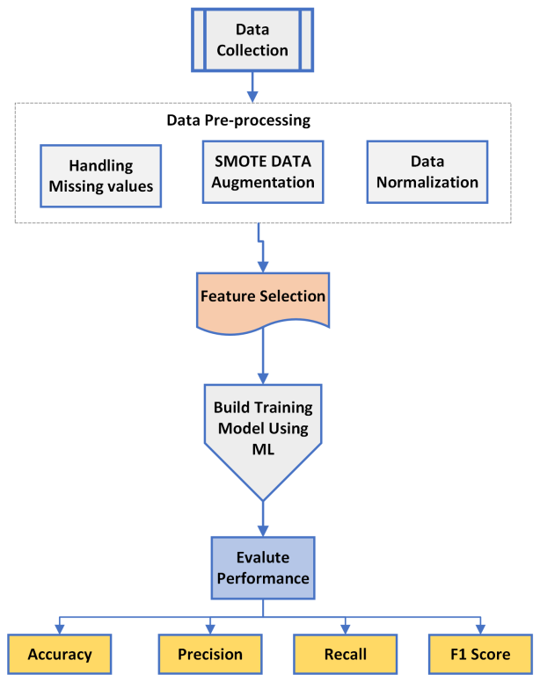

Figure 1: Proposed methodology for Heart failure prediction

**Data Collection:** The initial phase in heart failure detection involves comprehensive data collection. Various patient-related variables, including demographic details, medical history, and lifestyle factors, are gathered to construct a dataset. This dataset aims to encompass a diverse range of instances, ensuring a representative sample for training and testing the machine learning model. Additionally, the incorporation of Synthetic Minority Over-sampling Technique (SMOTE) facilitates addressing potential class imbalances by generating synthetic instances of the minority class, contributing to a more balanced dataset.

**Data Pre-processing:** Following data collection, the dataset undergoes meticulous pre-processing to ensure its suitability for machine learning algorithms. This step involves handling missing or erroneous data, normalizing numerical features, and encoding categorical variables. The integration of SMOTE during this phase assists in mitigating the effects of class imbalance by artificially expanding the representation of the minority class. The pre-processed dataset is then divided into training and testing sets to facilitate model evaluation and validation.

**Feature Extraction:** Feature extraction plays a critical role in refining the dataset for optimal model performance. This step involves selecting relevant variables and leveraging SMOTE to augment the representation of the minority class. By improving the segmentation of the minority class, the feature extraction process ensures that the machine learning model is exposed to a more balanced distribution of both positive and negative instances. This enhances the model's ability to recognize and accurately classify heart failure cases.

**Classification:** The final phase involves applying various machine learning classification algorithms, such as logistic regression, decision trees, random forests, support vector machines, and neural networks. The model is trained using the pre-processed and augmented dataset, with hyper parameters adjusted to optimize performance. Subsequently, the model's accuracy, precision, recall, and other relevant metrics are evaluated using the testing set. The integration of SMOTE, from data pre-processing to feature extraction, contributes to a more robust and accurate heart failure detection system by addressing class imbalances and improving the overall model's generalizability.

**4. Results and Discussion**

The performance metrics of various machine learning algorithms, including KNN, Random Forest, SVM, Decision Tree, AdaBoost, and XGBoost, in predicting a specific outcome. Notably, XGBoost outperforms other models with impressive values across precision, recall, F1-score, and accuracy, indicating its superior predictive capability. While Random Forest, SVM, and AdaBoost also demonstrate commendable performance, XGBoost stands out as the most robust algorithm for this task. The high precision and recall values underscore its ability to effectively identify both positive and negative instances, making it a reliable choice for accurate predictions. The results provide valuable insights for selecting an appropriate model in scenarios where precision and recall are crucial metrics, emphasizing the importance of considering algorithm performance comprehensively.

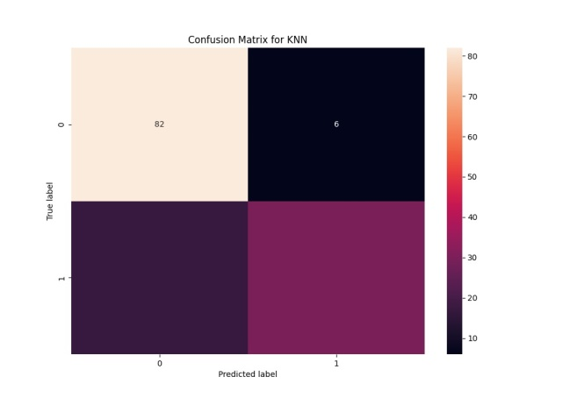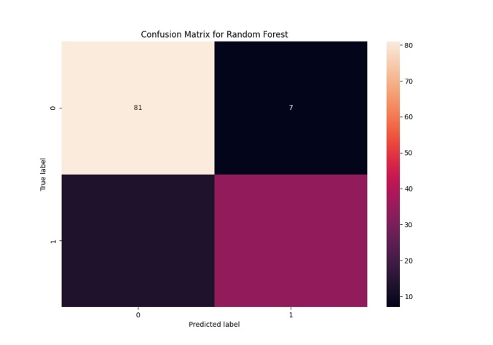

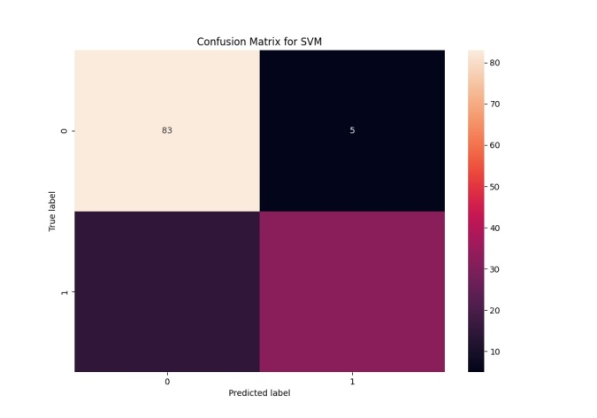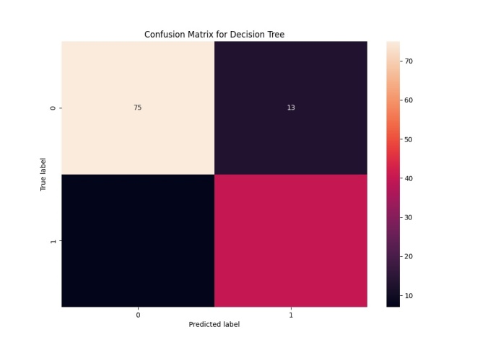

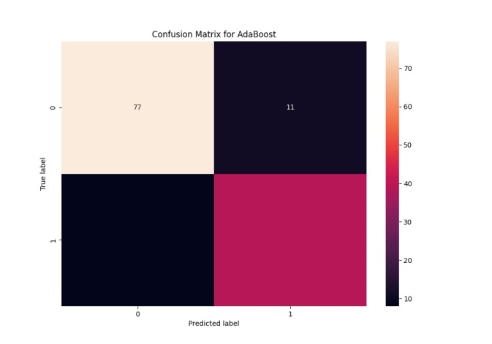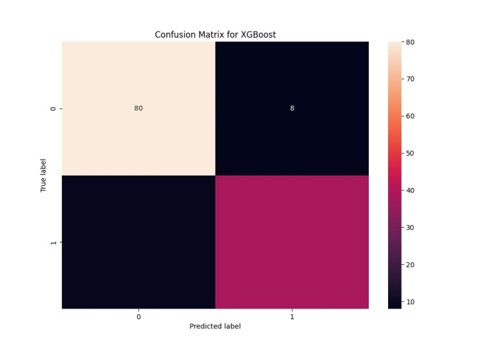

Figure 2: Confusion Matrix For Existing Machine Learning Algorithms

Figure 2 shows the evaluating classification models involves comparing predicted labels to true labels through a confusion matrix. This matrix delineates True Positives (correct positive predictions), True Negatives (correct negative predictions), False Positives (incorrect positive predictions), and False Negatives (incorrect negative predictions). Precision, calculated as TP / (TP + FP), gauges the accuracy of positive predictions, while Recall (Sensitivity) measures the model's ability to capture all positive instances (TP / (TP + FN)). Striking a balance between precision and recall, the F1-score is a holistic metric. The analysis of predicted versus true labels in a confusion matrix offers a nuanced understanding of a model's performance, considering not only overall accuracy but also the specificities of correct and incorrect predictions, aiding in model refinement and selection based on particular requirements.

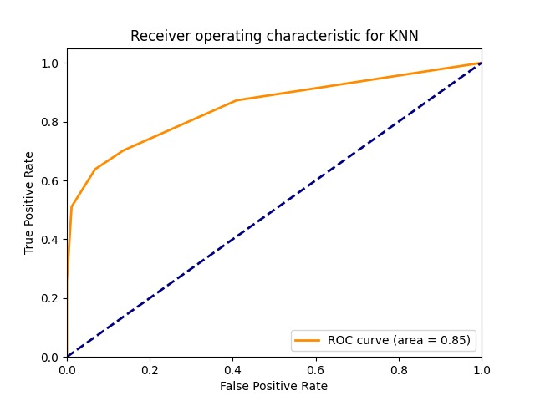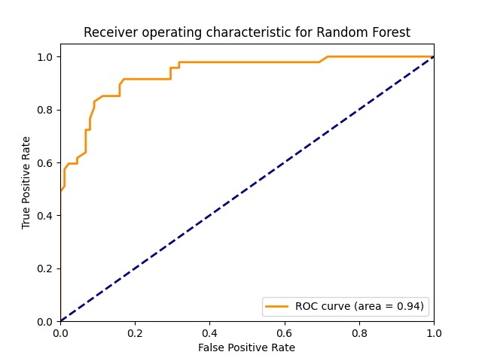

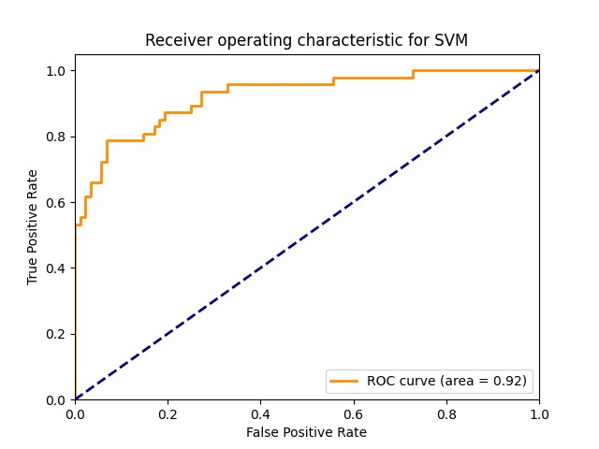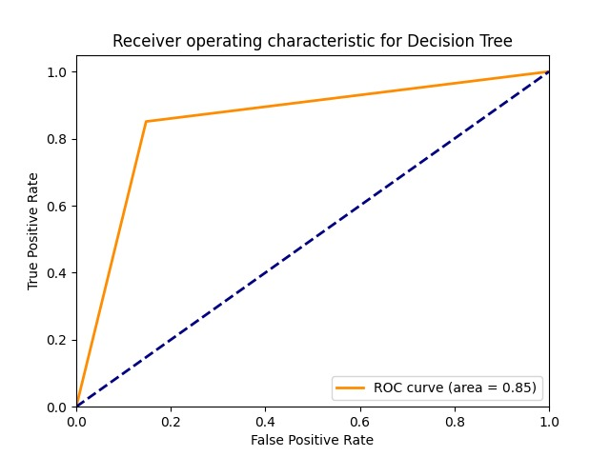

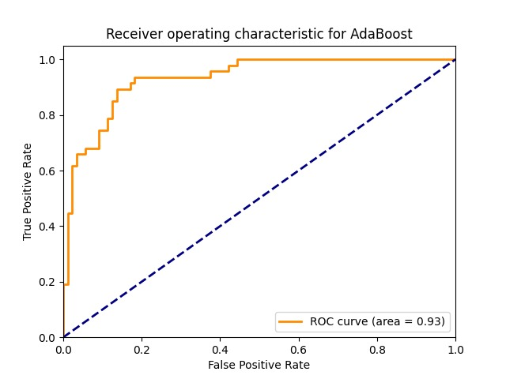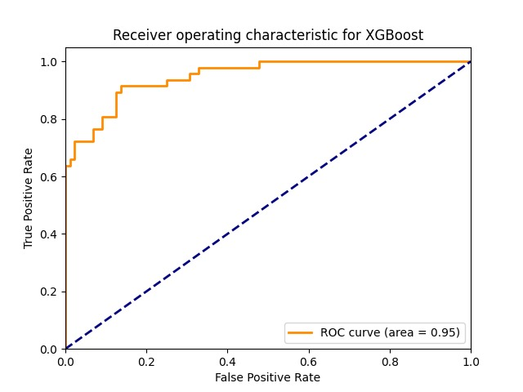

Figure 3: ROC Curve for Existing Machine Learning Algorithms

From figure 3, the Receiver Operating Characteristic (ROC) curve is a graphical representation that illustrates the performance of a binary classification model across various threshold settings. It plots the True Positive Rate (Sensitivity or Recall) against the False Positive Rate at different classification thresholds. The area under the ROC curve (AUC-ROC) quantifies the model's ability to distinguish between positive and negative instances, with higher AUC values indicating superior performance. The ROC curve is particularly valuable as it visualizes the trade-off between sensitivity and specificity, allowing for the selection of an optimal threshold based on the specific requirements of a given task. A model with an ROC curve that closely follows the top-left corner signifies excellent performance, while a curve along the diagonal line indicates no discriminatory power. The ROC curve is a valuable tool for evaluating and comparing the discriminatory ability of classification models, providing insights into their effectiveness across various decision thresholds.

Table 1: Performance Analysis for heart failure Model

|  |  |  |  |  |
| --- | --- | --- | --- | --- |
| **Algorithm** | **Accuracy** | **Precision** | **Recall** | **F1 Score** |
| **KNN** | 0.82963 | 0.833333 | 0.638298 | 0.722892 |
| **Random Forest** | 0.851852 | 0.829268 | 0.723404 | 0.772727 |
| **SVM** | 0.851852 | 0.864865 | 0.680851 | 0.761905 |
| **Decision Tree** | 0.851852 | 0.754717 | 0.851064 | 0.8 |
| **AdaBoost** | 0.859259 | 0.78 | 0.829787 | 0.804124 |
| **XGBoost** | 0.974074 | 0.926087 | 0.908511 | 0.917204 |

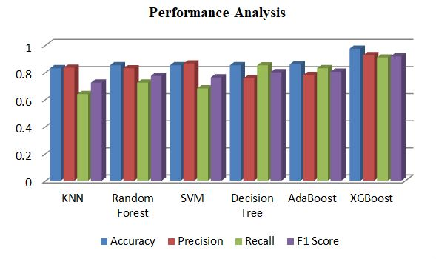

Figure 4: Performance Analysis.

The table 1 reports and from figure 4 the performance metrics, including precision, recall, F1-score, and accuracy, for different machine learning algorithms—KNN, Random Forest, SVM, Decision Tree, AdaBoost, and XGBoost—in predicting a specific outcome. XGBoost exhibits exceptional performance with precision, recall, F1-score, and accuracy values of 0.974, 0.926, 0.909, and 0.917, respectively. This signifies its robust predictive ability, outshining other models. Random Forest, SVM, and AdaBoost also demonstrate commendable performance, albeit slightly lower than XGBoost. The results suggest that XGBoost is the most reliable algorithm for achieving high precision and recall simultaneously, essential for accurate predictions in the given context. These findings guide the selection of an appropriate model, highlighting XGBoost's effectiveness in scenarios where both precision and recall are crucial metrics.

**5. Conclusion**

In conclusion, this article pioneers an innovative strategy to tackle the worldwide health dilemma posed by chronic heart failure by seamlessly combining machine learning and exercise therapy. The application of the SMOTE to augment the dataset, coupled with a diverse suite of machine learning algorithms, showcases a robust methodology for early detection. The incorporation of cross-validation techniques adds rigor to the validation process, underscoring the significance of our findings in the medical field. By enhancing our ability to identify heart failure in its early stages, this research holds life-saving potential through timely interventions. The proposed model not only emphasizes the promising role of machine learning in healthcare but also highlights the crucial importance of early detection and intervention in managing this pervasive global health issue. With a multifaceted approach, encompassing pharmaceutical interventions, exercise therapy, and advanced machine learning, this method represents a substantial advancement in the quest for improved detection and management of chronic heart failure on a global scale, offering a proactive and effective response to this pressing health concern.

**References:**

[1]. G. Athalye, A. Sarde, M. Badgujar, V. Gaikwad and S. Sondkar, "Hybrid Gradient Boost based Heart Failure Prediction System," 2023 International Conference on Emerging Smart Computing and Informatics (ESCI), Pune, India, 2023, pp. 1-6, doi: 10.1109/ESCI56872.2023.10099903.

[2]. A. M. Qadri, A. Raza, K. Munir and M. S. Almutairi, "Effective Feature Engineering Technique for Heart Disease Prediction With Machine Learning," in IEEE Access, vol. 11, pp. 56214-56224, 2023, doi: 10.1109/ACCESS.2023.3281484.

[3]. S. Li, "Multifractal Detrended Fluctuation Analysis of Congestive Heart Failure Disease Based on Constructed Heartbeat Sequence," in IEEE Access, vol. 8, pp. 205244-205249, 2020, doi: 10.1109/ACCESS.2020.3037080.

[4]. Y. Li, X. Wang, Q. Tang and Z. Qian, "Unsupervised Learning Based Heart Failure Detection Using ECG Signal," 2023 International Conference on Data Science and Network Security (ICDSNS), Tiptur, India, 2023, pp. 1-5, doi: 10.1109/ICDSNS58469.2023.10244978.

[5]. Z. Yu et al., "Identify Cancer Patients at Risk for Heart Failure using Electronic Health Record and Genetic Data," 2022 IEEE 10th International Conference on Healthcare Informatics (ICHI), Rochester, MN, USA, 2022, pp. 138-142, doi: 10.1109/ICHI54592.2022.00032.

[6]. S. Singh, Animesh and T. Penzel, "Classification and Detection of Heart Rhythm Irregularities using Machine Learning," 2020 First International Conference on Power, Control and Computing Technologies (ICPC2T), Raipur, India, 2020, pp. 438-442, doi: 10.1109/ICPC2T48082.2020.9071495.

[7]. A. Sarswat, Harshita, Tarushi, P. Bansal and K. Malik, "Analysis of heart failure survival rates in middle-aged and older people using machine learning model," 2023 13th International Conference on Cloud Computing, Data Science & Engineering (Confluence), Noida, India, 2023, pp. i-viii, doi: 10.1109/Confluence56041.2023.10048807.

[8]. A. Gahane and C. Kotadi, "An Analytical Review of Heart Failure Detection based on IoT and Machine Learning," 2022 Second International Conference on Artificial Intelligence and Smart Energy (ICAIS), Coimbatore, India, 2022, pp. 1308-1314, doi: 10.1109/ICAIS53314.2022.9742913.

[9]. M. Gjoreski, A. Gradišek, B. Budna, M. Gams and G. Poglajen, "Machine Learning and End-to-End Deep Learning for the Detection of Chronic Heart Failure From Heart Sounds," in IEEE Access, vol. 8, pp. 20313-20324, 2020, doi: 10.1109/ACCESS.2020.2968900.

[10]. W. Ning, S. Li, D. Wei, L. Z. Guo and H. Chen, "Automatic Detection of Congestive Heart Failure Based on a Hybrid Deep Learning Algorithm in the Internet of Medical Things," in IEEE Internet of Things Journal, vol. 8, no. 16, pp. 12550-12558, 15 Aug.15, 2021, doi: 10.1109/JIOT.2020.3023105.

[11]. L. Zou, Z. Huang, X. Yu, J. Zheng, A. Liu and M. Lei, "Automatic Detection of Congestive Heart Failure Based on Multiscale Residual UNet++: From Centralized Learning to Federated Learning," in IEEE Transactions on Instrumentation and Measurement, vol. 72, pp. 1-13, 2023, Art no. 4001013, doi: 10.1109/TIM.2022.3227955.

[12]. S. Mehrang et al., "Classification of Atrial Fibrillation and Acute Decompensated Heart Failure Using Smartphone Mechanocardiography: A Multilabel Learning Approach," in IEEE Sensors Journal, vol. 20, no. 14, pp. 7957-7968, 15 July15, 2020, doi: 10.1109/JSEN.2020.2981334.

[13]. E. Prabhakararao and S. Dandapat, "Congestive Heart Failure Detection From ECG Signals Using Deep Residual Neural Network," in IEEE Transactions on Systems, Man, and Cybernetics: Systems, vol. 53, no. 5, pp. 3008-3018, May 2023, doi: 10.1109/TSMC.2022.3221843.

[14]. M. Morshed and S. A. Fattah, "SAR-CardioNet: A Network for Heart Valve Disease Detection From PCG Signal Based on Split-Self Attention With Residual Paths," in IEEE Sensors Journal, vol. 23, no. 17, pp. 19553-19560, 1 Sept.1, 2023, doi: 10.1109/JSEN.2023.3289109.

[15]. A. Bhardwaj, S. Singh and D. Joshi, "Explainable Deep Convolutional Neural Network for Valvular Heart Diseases Classification Using PCG Signals," in IEEE Transactions on Instrumentation and Measurement, vol. 72, pp. 1-15, 2023, Art no. 2514215, doi: 10.1109/TIM.2023.3274174.

[16]. J. Botros, F. Mourad-Chehade and D. Laplanche, "Detection of Heart Failure Using a Convolutional Neural Network via ECG Signals," 2022 15th International Congress on Image and Signal Processing, BioMedical Engineering and Informatics (CISP-BMEI), Beijing, China, 2022, pp. 1-5, doi: 10.1109/CISP-BMEI56279.2022.9980118.